Worksheet 1: Power Management & Bootloading
Desk Satellite Weather Station
Summer Hardware Practicum
Deadline: 后天晚上 12:00 前 (2-day assignment)
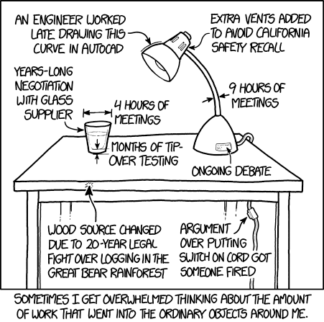

Overview
This worksheet focuses on design related to our first module - namely power management and bootloading. The design questions below are quite open-ended as the goal is for you to develop creativity and critical thinking in designing an embedded system and not focus so much on arriving at a correct answer - as we know, there is more than one way to solve a design problem. Be verbose in your explanations, and reason through your decisions as explicitly as possible.
Find the assignment repository, which includes a starter codebase for you. Don't forget to review the course submission guide for details on submitting assignments.
All the required questions are highlighted in green.
Important notes are highlighted in yellow.
An individual submission to be submitted on GitHub.

Design 1: An Autonomous Vehicle
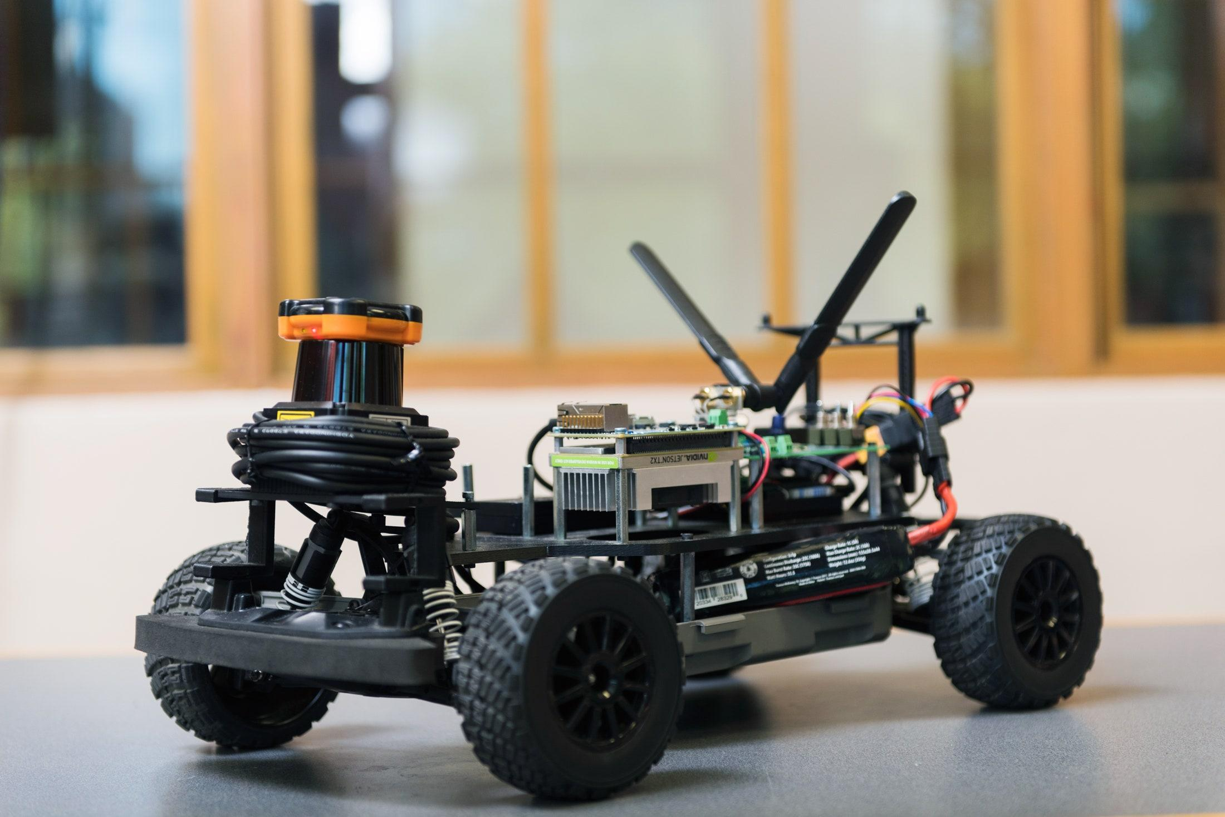
The F1TENTH vehicle requires a new power distribution board. After going through a number of hardware updates, there is a new set of power requirements. Given the input voltage listed below, design a power management system that can provide the required power to the peripherals.
Input voltage:
- 3S Lithium Polymer Battery, with a C rating and current capacity that far exceeds your needs
  - 3S means 3 lithium polymer cells in Series (if would be 3P if they were in Parallel). The “depleted” voltage for one cell is 3.0V and a fully charged cell sits at 4.2V.
  - What is the 3S LiPo voltage range? Voltage range is the lowest and highest voltages possible with the power source.
  - When would you connect voltage cells in series and in parallel? What are the tradeoffs in terms of voltage and current supplied?
Peripherals:
- LiDAR that runs on 12V and can draw up to 1A
- Jetson Xavier NX that runs on 5V and can draw up to 3A (This is the microprocessor!)
- Camera that runs on 5V and can draw up to 1.5A
- For the purpose of this exercise, you may ignore the motors & motor control.
First, make a simple block diagram that shows all of the important devices included in the system. There is no need to include passive components (capacitors, resistors, inductors) on the block diagram - just the most critical components needed for the device to operate. However, don’t forget to add the power regulators needed in your system (these aren’t shown in the example below).
Below is an example of a simple block diagram used for an Internet of Things (IoT) smart plant watering device. Create your diagram with software, such as yEd (used to make the diagram below) or Diagrams.net (can link to your GitHub repository!)
Only power must be routed in this diagram! Data is not required.
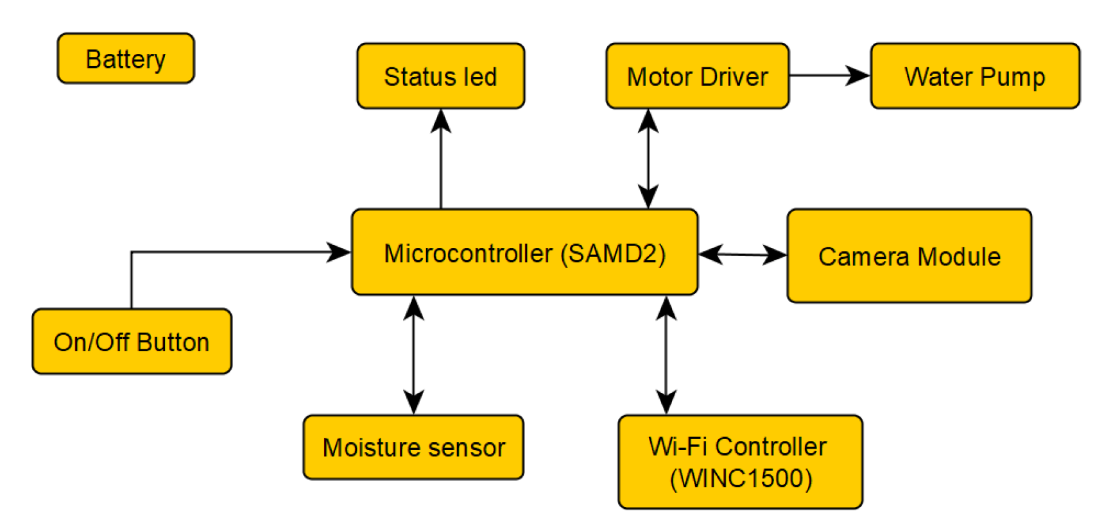

Next, use Mouser or DigiKey to source your parts. This is also a practice in learning how to filter and look for parts. In general, you’ll want to start with “In Stock” and “Active” to ensure parts availability and from there, narrow the search to your specifications. Assume you are using the peripherals listed above (LiDAR, Jetson, Camera). We want you to work on the power configuration for this system only.
You must source the parts that your power components need as well. E.g. If a switching regulator requires a 1.4mH inductor, 22uF capacitor, and 1kOhm resistor, you must also source those components. When sourcing your part, you must read the datasheets. For example, if you want a switch in your circuit, not all switches are rated up to 5A! 🔥
Keep in mind that we want you to build a chip-down design - finding a module with all parts included in a black box will not receive credit. We want you to understand what goes into making these DC/DC regulator power management ICs (PMICs). This is an example of what we’re expecting to see (link):
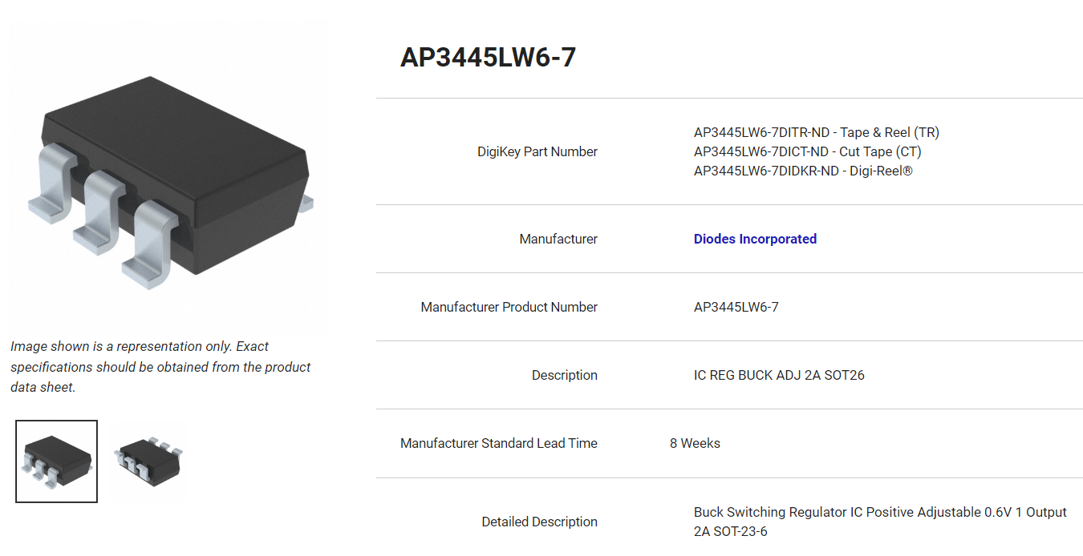
When you review its datasheet, you’ll see that it requires a few external components to operate properly.
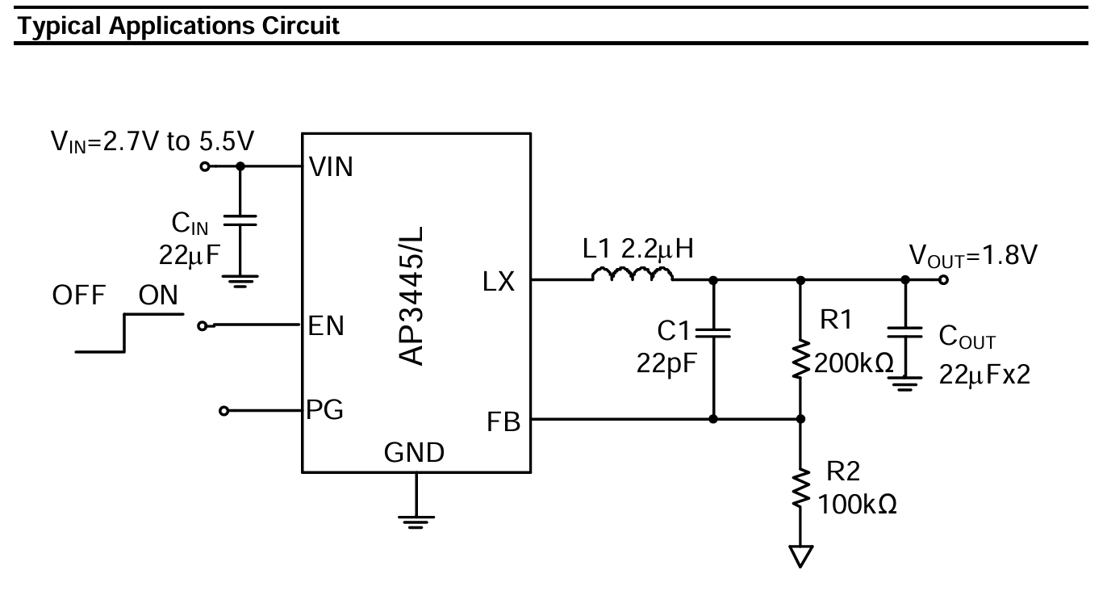
The image below shows a part that would not be given credit. See how everything is built into the device?
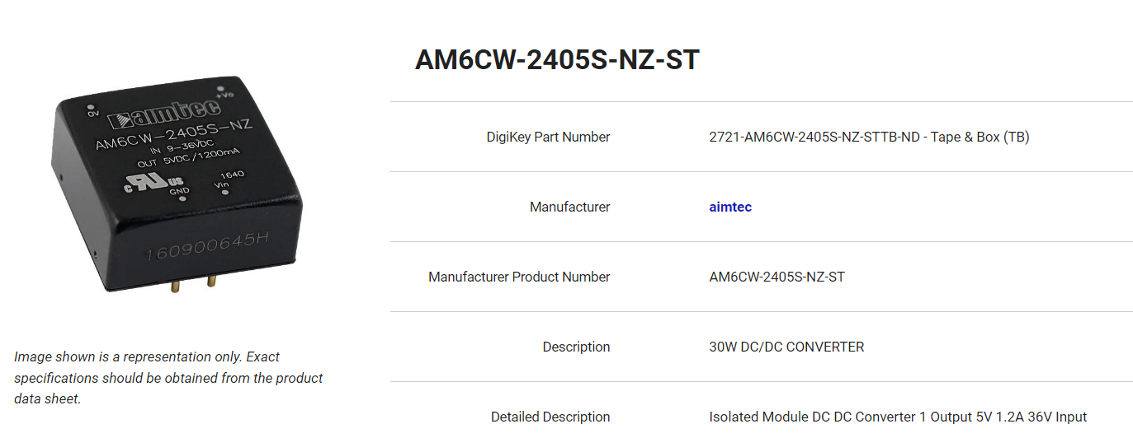
Justify your design and parts decisions. Essentially, this question asks you to look into the components that make up voltage regulators, but you can expand on this design. Possible designs can range from very simple (one or two ICs) to a bit more complicated. For example, do you want to have switches? Do you want to make this the least expensive design, most efficient, or smallest?
The WEBENCH Power Designer and ST eDesignSuite may be helpful in creating power supply circuits. Cite your work! If using these resources, run simulations and copy the circuit details into the assignment submission.
Use the provided WS1 - Power - Sample BOM.xlsx to record your parts in the Design 1 tab.

Submission
(S1) A simple block diagram representing Design 1. Commit the source file and embed an image of the block diagram in the README.md file. Only power wiring is required.
(R1) Fill out your part choices in the Design 1 tab of WS1 - Power - Sample BOM.xlsx.
(R2) A written explanation of your part choices in the README.md file.

Design 2: Peter Parker Needs Your Help
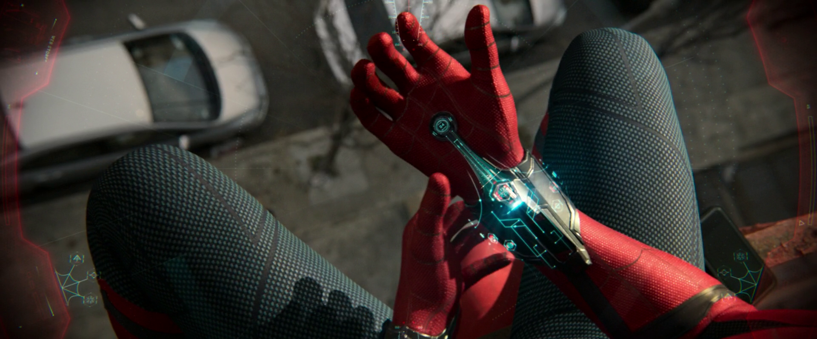
Peter Parker is a technical genius, but he needs your help because he is short on time. He wants to redesign his web shooters since they’re getting a bit old and outdated and keeps running out of power. He’s tired of having to carry around a backpack full of extra web shooters and back up batteries along. He doesn’t have time to make changes on the web chemistry or physical mechanism. His focus is on changing the electronics for now. Fighting crime is time sensitive!
Peter wants to upgrade his web shooter to include a few new features:
- Speaker to play music (every superhero needs a cool entry soundtrack!)
- Heart rate monitor (everyone is on the fitness trend now and Peter refuses to be left out)
- High Power LED (crime usually happens in dark or dimly lit locations)
- Voice recorder (so he can keep a diary of his adventures and write his novel when he retires)
His web shooter requires an input voltage of 5V and can draw up to 200mA in order to function properly. He found a slim and fancy DC power supply that outputs 20V and a max current of 5A.
As with Design 1, first make a simple block diagram that shows all of the important devices included in the system. There is no need to include passive components (capacitors, resistors, inductors) - just the most critical components needed for the device to operate. Both power and data must be routed in this diagram.
Next, using DigiKey to find parts that satisfy his requirements above (the sensors, actuators). Namely, pick out a sensor or IC for each of the points above and explain why you chose each part. There is no one correct answer. This question is to help you gain familiarity with searching for components on DigiKey based on a set of requirements. Pro tip: Adafruit, and Sparkfun have most/all of their components listed for sale, so you might also enjoy starting with those websites first, then searching their part number on DigiKey.
For this question, you do not need to also search for the required passives of the ICs, such as capacitors, resistors, and inductors - we shall assume these are just all given. For example, if the heart rate monitor that you picked requires 2 capacitors, 1 inductor, and an op amp according to the data sheet, we’ll assume this all comes in a package.
Furthermore, consider the power management required to power all the components you picked in addition to the 5V web shooter. You DO need to source the required passive for power management.
Assume that the MCU you are given is the ATMega328PB.
Here are a few design questions to think about:
- Does physical size matter? E.g., If you need a linear voltage regulator, should you pick a through-hole part or a surface mount part?
- How bright should the LED be? How does that affect the part choice?
- Do you need any voltage regulators? If so, what kind?
- Would a low-voltage detector be useful?
Feel free to add extra features as well. Peter has decided that he is committed to carrying a backpack around (he always has a packed lunch and a filled water bottle as well as some cookies), so for all we know, he probably carries around a full-sized oscilloscope. We will assume that he has no problem carrying a bunch of gadgets around.
Unfortunately, Peter Parker is not allowed to own a smartwatch, so zero points will be given if a link to a smartwatch is included on the BOM.
Use the same WS1 - Power - Sample BOM.xlsx to record your parts in the Design 2 tab.

Submission
(S2) A simple block diagram representing Design 2. Commit the source file and embed an image of the block diagram in the README.md file. Both power and data should be routed.
(R3) Fill out your part choices in the Design 2 tab of WS1 - Power - Sample BOM.xlsx.
(R4) A written explanation of your part choices in the README.md file.

Short Answers
(R5) What are two ways to step down the voltage of a DC power supply to a predetermined level?
(R6) List 3 advantages and 3 disadvantages for each method.
(R7) Describe a situation where you would prefer the first method over the second.
(R8) Describe a situation where you would prefer the second method instead.

Submission Requirements
You will submit your assignment through your GitHub repository commits. See the course submission guide for more information about the submission process.

Grading Rubric
Only the README.md and linked files in your GitHub repository will be graded. If your solution(s) used any additional files or dependencies, you MUST specify this in your README.md.
Questions | Points | Number | Total
R5-R8 | 2 pt(s) | 4 | 2 x 4 = 8 pt(s)
R1-R4 | 6 pt(s) | 4 | 6 x 4 = 24 pt(s)
S1-S2 | 6 pt(s) | 2 | 6 x 2 = 12 pt(s)
Grand Total |  |  | 44 points

https://xkcd.com/1741/
https://www.wired.com/story/small-cars-help-drive-autonomous-future/
https://marvelcinematicuniverse.fandom.com/wiki/Web-Shooters

